Manitoba Arabian Horse Association
Presents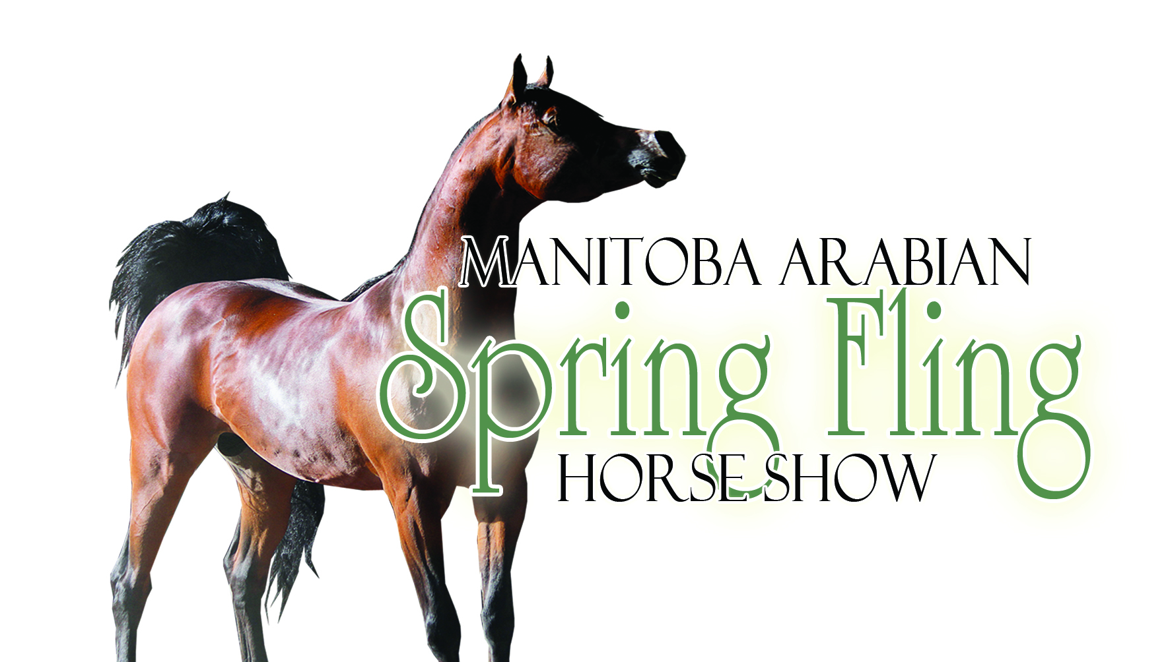
May 11-12, 2013
Keystone Centre, Brandon, MB, Canada
Region 17 Qualifying Show

Show Secretary: Chantelle Rutledge Show Organizer: Valerie Batt
Po Box 535 Po Box 22042
Oxbow, Sk Brandon, MB,
S0C 2B0 R7A 4G8
306-483-2434 204-573-1737(cell)
sahashowscretary@hotmail.com 204-727-3661(Office)
valabatt@gmail.com

Entries Close: Sunday April 22, 2013

"BLUE DOT SALE"
Have you got a stallion you would like to show off at the show? Stallions at the shows that are "for stud" have a Blue Dot placed on their show number and are listed in the show program for a fee. People viewing the show will know when watching classes which stallions are for stud and can view their information or who to contact about them, in the show program.
Fees for the "Blue Dot Sale":
Option One: $10.00 Listing in show program with the name of you and your horse and contact information if paid by April 1, 2013, or $20.00 after the cut-off date.
Option Two: $40 Listing in show program as above PLUS a black and white picture and 150 word blurb about the horse.

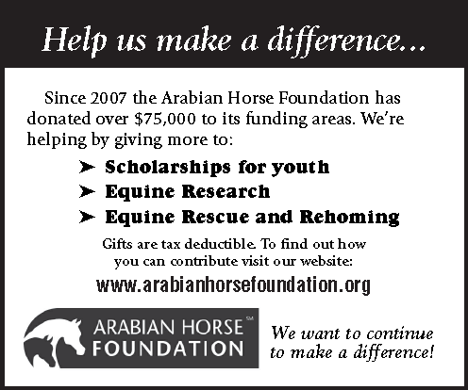

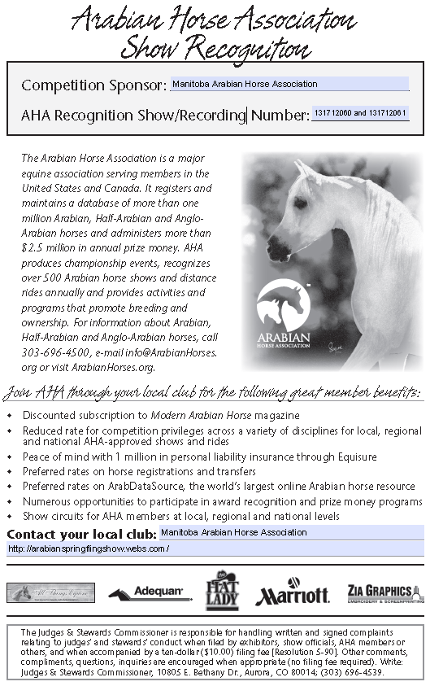

RED DOT SALE:
Have you got a horse you would like to sell at the show? Horses at the shows that are "for sale" have a Red Dot placed on their show number and are listed in the show program for a fee. People viewing the show will know when watching classes which horses are for sale and can view their information or who to contact about them, in the show program.
Fees for the "Red Dot Sale":
Option One: $10.00 Listing in show program with the name of you and your horse and contact information if paid by April 1, 2013,
or $20.00 after the cut-off date.
Option Two: $40 Listing in show program as above PLUS a black and white picture and 150 word blurb about the horse

Thank you Renee Lupien, of Veracity Ventures, for this great Red/Blue Dot Suggestion!

Classes Offered Page #1

Classes Offered  Cl # ClassTitle  Sat Sun  BREEDING/IN-HAND  1 1 Arabian fillies  2 2 Arabian Mare Breeding  3 3 * Arabian Mare Breeding 2 yr. & Over  7 7 Arabian Geldings/colts  8 8 Arabian Gelding In-Hand  9 9 *Arabian Gelding In-Hand AAO 2 & Over  13 13 Arabian Stallion Breeding  14 14 *Arabian Stallion Breeding 2 yr. & Over  4 4 HA/AA Fillies  5 5 HA/AA Mare Breeding  6 6 * HA/AA Mare Breeding 2 yr. & Over  10 10 HA/AA Colts/geldings  11 11 HA/AA Gelding In-Hand  12 12 *HA/AA Gelding In-Hand 2 yr. & Over  ENGLISH PLEASURE  47 73 *Arabian English Pleasure  33 83 *Arabian English Pleasure AAO  52 69 Arabian English Pleasure ATR  78 52 Arabian English Pleasure JTR  71 57 Arabian English Pleasure Junior Horse  40 78 *HA/AA English Pleasure  66 61 *HA/AA English Pleasure AAO  43 76 HA/AA English Pleasure ATR  48 72 HA/AA English Pleasure JTR  81 49 HA/AA English Pleasure Junior Horse  ENGLISH SHOW HACK  56 66 Arabian English Show Hack  67 60 Arabian English Show Hack ATR  79 51 HA/AA English Show Hack  COUNTRY ENGLISH PLEASURE  29 79 *Arabian Country English Pleasure  49 71 *Arabian Country English Pleasure AAO  55 67 Arabian Country English Pleasure ATR  36 81 Arabian Country English Pleasure JTR  35 82 *HA/AA Country English Pleasure  76 53 *HA/AA Country English Pleasure AAO  59 65 HA/AA Country English Pleasure ATR  74 56 HA/AA Country English Pleasure JTR  83 87 HA/AA Country English Pleasure AAOTR 40 and over  WESTERN PLEASURE ARABIAN  90 41 *Arabian Western Pleasure  95 36 *Arabian Western Pleasure AAO  99 32 Arabian Western Pleasure ATR  85 47 Arabian Western Pleasure JTR  104 28 Arabian Western Pleasure Junior Horse  106 26 Arabian Western Pleasure AATR  97 34 *HA/AA Western Pleasure  105 27 *HA/AA Western Pleasure AAO  89 42 HA/AA Western Pleasure ATR  94 37 HA/AA Western Pleasure JTR  101 31 HA/AA Western Pleasure Junior Horse | Cl # ClassTitle  Sat Sun  TRAIL  NA 20 Arabian English Trail Horse  NA 24 Arabian Western Trail Horse  NA 17 Arabian Western Trail Horse ATR  NA 22 Arabian Western Trail Horse JTR  NA 18 HA/AA English Trail Horse  NA 23 HA/AA Western Trail Horse  NA 21 HA/AA Western Trail Horse ATR  NA 16 HA/AA Western Trail Horse JTR  LADIES SIDE SADDLE  38 86 Arabian Ladies Side Saddle  63 63 HA/AA Ladies Side Saddle  REINING HORSE  102 30 *Arabian Reining Horse  93 38 Arabian Reining Horse ATR  108 43 Arabian Reining Horse JTR  86 46 *Arabian Reining AAO  107 25 *HA/AA Reining Horse  91 40 *HA/AA Reining Horse AAO  88 44 HA/AA Reining Horse ATR  98 33 HA/AA Reining Horse JTR  SPORT HORSE IN-HAND  26 NA Arabian Sport Horse Mares In Hand  24 NA *Arabian SH Mares In Hand AT 2 yr & over  16 NA Arabian Sport Horse Stallions In Hand  18 NA Arabian Sport Horse Stallions In Hand AT  22 NA Arabian Sport Horse Geldings In Hand  20 NA *Arabian SH Geldings In Hand AT 2 yr & over  25 NA HA/AA Sport Horse Mares In Hand  23 NA *HA/AA Sport Horse Mares In Hand AT 2 yr & over  17 NA HA/AA Sport Horse Stallions In Hand  15 NA HA/AA Sport Horse Stallions In Hand AT  21 NA HA/AA Sport Horse Geldings In Hand  19 NA *HA/AA SH Geldings In Hand AT 2 yr & over  SPORT HORSE UNDER SADDLE  34 NA *Arabian Sport Horse Under Saddle  46 NA *Arabian Sport Horse Under Saddle ATR  57 NA Arabian Sport Horse Under Saddle JTR  39 NA Arabian Sport Horse Under Saddle Junior horse  28 NA *HA/AA Sport Horse Under Saddle  42 NA *HA/AA Sport Horse Under Saddle ATR  65 NA *HA/AA Sport Horse Under Saddle JTR  53 NA HA/AA Sport Horse Under Saddle Select AATR  60 NA HA/AA Sport Horse Under Saddle AATR  72 NA HA/AA Sport Horse Under Saddle AAOTR  31 NA HA/AA Sport Horse Under Saddle Select ATR  SPORT HORSE SHOW HACK  73 NA Arabian Sport Horse Show Hack  62 NA Arabian Sport Horse Show Hack ATR  77 NA Arabian Sport Horse Show Hack JTR  82 NA HA/AA Sport Horse Show Hack  69 NA HA/AA Sport Horse Show Hack ATR  50 NA HA/AA Sport Horse Show Hack JTR

Classes Offered Page #2

HUNTER PLEASURE ARABIAN  64 62 *Arabian Hunter Pleasure  44 75 *Arabian Hunter Pleasure AAO  61 64 Arabian Hunter Pleasure ATR  30 85 Arabian Hunter Pleasure JTR  41 77 Arabian Hunter Pleasure Junior Horse  75 54 Arabian Hunter Pleasure ATR 19 - 39  80 50 Arabian Hunter Pleasure ATR 40 and over  70 58 *HA/AA Hunter Pleasure  37 80 *HA/AA Hunter Pleasure AAO  32 84 HA/AA Hunter Pleasure ATR  51 70 HA/AA Hunter Pleasure JTR  54 68 HA/AA Hunter Pleasure Junior Horse | MISC  68 59 Lead Line English All Seats ages 2 –6  103 29 Lead Line Western ages 2 –6  84 48 Pleasure Walk/Trot 10 & Under  NA 19 Trail Walk/Trot 10 & Under  58 55 Equitation Walk/Trot 10 & Under  45 74 Saddle Seat Equitation AT  96 35 Reining Seat Equitation AT  27 15 Showmanship AT  87 45 Western Horsemanship AT  92 39 Western Seat AT
*Sweepstakes classes
TBA Classes
Choose the TBA class you need by the AHA code number and pay $25.00 for each TBA class. You may slot the class where you want it if you are the first to request that class but you need to call the Show Secretary to find that out otherwise it will be slotted where there is an opening. As long as there is time in the schedule.
IF YOU ARE INTERESTED IN ANY TBA CLASSES –PLEASE CONTACT
SHOW SECRETARY ASAP SO THEY CAN GET PUT IN CLASS LIST AS
SPACE IS LIMITED!
*********************************************************************************
PLEASE NOTE
NEW TBA OPTIONS!
ANY CLASS ON THE “AHA CLASS LIST” THAT IS
RECOGNIZED BY AHA, WITH THE EXCEPTION OF
DRESSAGE, CUTTING, REINED COW, OR
WORKING HUNTER CAN NOW BE ADDED IF
ENTRIES WARRANT OR CLASS IS SPONSORED!
*********************************************************************************
AHA MEMBERSHIP STATEMENT
EACH COMPETITOR (THIS INCLUDES AT LEAST ONE RECORDED OWNER AND ALL TRAINERS, DRIVERS, RIDERS, HALTER HANDLERS, COACHES AND THE PERSON(S) SIGNING THE ENTRY BLANK) IN AN ARABIAN HORSE ASSOCIATION RECOGNIZED ARABIAN DIVISION, AT THE TIME OF ENTRY INTO A COMPETITION, MUST SUBMIT A COPY OF A VALID AHA MEMBERSHIP/COMPETITION CARD, JOIN AHA OR PAY AN AHA SINGLE EVENT MEMBERSHIP FEE PER COMPETITOR.
WHEN AN AGENT SIGNS FOR THE OWNER AT AN AHA RECOGNIZED COMPETITION, BOTH THE OWNER AND AGENT MUST BE MEMBERS OF AHA OR PAY THE AHA SINGLE EVENT MEMBERSHIP.
SINGLE EVENT MEMBERSHIP IS NOT ACCEPTABLE AT AHA REGIONAL OR NATIONAL COMPETITIONS.
EXHIBITORS IN WALK-TROT CLASSES ARE EXEMPT FROM AHA MEMBERSHIP REQUIREMENTS AT QUALIFYING COMPETITIONS, BUT MUST HAVE AN AHA MEMBERSHIP WITH COMPETITION CARD AT AHA REGIONAL AND NATIONAL COMPETITIONS.
EXHIBITITORS IN LEAD LINE CLASSES OR PARENTS/GUARDIANS SIGNING FOR MINORS ARE EXEMPT FROM AHA MEMBERSHIP REQUIREMENTS. (BOD 5/12)
JOTR/JOTD - Junior Owner to Ride/Junior Owner to Drive.
AAOTR/AAOTD - Adult Amateur Owner to Ride/Adult Amateur Owner to Drive. Refer to GR105, GR1306, and GR106 respectively.
AOTR/AOTD - Amateur Owner to Ride/Amateur Owner to Drive. Refer to General Rules, Rules GR1306 and GR106 respectively.
JTR/JTD - Junior Exhibitor to Ride/Junior Exhibitor to Drive. Refer to GR127.
ATR/ATD/AATR -Amateur to Ride/Amateur to Drive/Adult Amateur to Ride. Refer to GR1306.
SELECT - AOT, AAOT, AT, AAT, JOT, JT - - Competitors in the Arabian, Half-Arabian, or Anglo-Arabian Divisions shall not be considered separately when competing in the same performance or breeding/halter section. If a competitor is eligible to compete as a Select Rider/Driver/Handler in a section on December 1, said eligibility remains throughout the current competition year.
AOTS - Amateur Owned, Trained, and Shown. Please refer to http://usef.org/ for rules on this.
Manitoba Arabian Horse Association
Manitoba Arabian Spring Fling
May 11, 2013
#131712060 Region 17 Ribbons Awarded 1st – 6th place
Judge: Terry Johnson [R] of Surrey, BC

Order of Go AHA# Class Description
1. 1 Arabian Fillies
2. 1 Arabian Mare Breeding
3. 8 *Arabian Mare Breeding 2 yr. & Over
4. 400 HA/AA Fillies
5. 400 Half-Arabian/Anglo-Arabian Mare Breeding
6. 422 *Half-Arabian/Anglo-Arabian Mare Breeding 2 yr. & Over
7. 14 Arabian Geldings/Colts
8. 26 Arabian Gelding In-Hand
9. 33 *Arabian Gelding In-Hand AAO 2 & Over
10. 450 HA/AA Colts/Geldings
11. 450 Half-Arabian/Anglo-Arabian Gelding In-Hand
12. 472 *Half-Arabian/Anglo-Arabian Gelding In-Hand 2 yr. & Over
13. 14 Arabian Stallion Breeding
14. 19 *Arabian Stallion Breeding 2 yr. & Over
15. 488 Half-Arabian/Anglo-Arabian Sport Horse Stallions In Hand AT
16. 46 Arabian Sport Horse Stallions In Hand
17. 484 Half-Arabian/Anglo-Arabian Sport Horse Stallions In Hand
18. 50 Arabian Sport Horse Stallions In Hand AT
19. 1029 *Half-Arabian/Anglo-Arabian Sport Horse Geldings In Hand AT 2 yr & over
20. 59 *Arabian Sport Horse Geldings In Hand AT 2 yr & over
21. 494 Half-Arabian/Anglo-Arabian Sport Horse Geldings In Hand
22. 53 Arabian Sport Horse Geldings In Hand
23. 1028 *Half-Arabian/Anglo-Arabian Sport Horse Mares In Hand AT 2 yr & over
24. 45 *Arabian Sport Horse Mares In Hand AT 2 yr & over
25. 475 Half-Arabian/Anglo-Arabian Sport Horse Mares In Hand
26. 39 Arabian Sport Horse Mares In Hand
A. *** TBA
27. 918 Showmanship AT
28. 773 *Half-Arabian/Anglo-Arabian Sport Horse Under Saddle
29. 95 *Arabian Country English Pleasure
30. 299 Arabian Hunter Pleasure JTR
31. 1092 HA/AA Sport Horse Under Saddle Select ATR
32. 741 Half-Arabian/Anglo-Arabian Hunter Pleasure ATR
33. 94 *Arabian English Pleasure AAO
34. 335 *Arabian Sport Horse Under Saddle
35. 540 *Half-Arabian/Anglo-Arabian Country English Pleasure
B. *** TBA
36. 104 Arabian Country English Pleasure JTR
37. 752 *Half-Arabian/Anglo-Arabian Hunter Pleasure AAO
38. 165 Arabian Ladies Side Saddle
39. 341 Arabian Sport Horse Under Saddle Junior horse
40. 515 *Half-Arabian/Anglo-Arabian English Pleasure
41. 305 Arabian Hunter Pleasure Junior Horse
42. 777 *Half-Arabian/Anglo-Arabian Sport Horse Under Saddle ATR
43. 524 Half-Arabian/Anglo-Arabian English Pleasure ATR
44. 309 *Arabian Hunter Pleasure AAO
45. 925 Saddle Seat Equitation AT
46. 339 *Arabian Sport Horse Under Saddle ATR
47. 75 *Arabian English Pleasure
C. *** TBA
48. 524 Half-Arabian/Anglo-Arabian English Pleasure JTR
D. *** TBA
49. 115 *Arabian Country English Pleasure AAO
50. 1054 Half-Arabian/Anglo-Arabian Sport Horse Show Hack JTR

51. 741 Half-Arabian/Anglo-Arabian Hunter Pleasure JTR
52. 83 Arabian English Pleasure ATR
53. 1091 HA/AA Sport Horse Under Saddle Select AATR
54. 748 Half-Arabian/Anglo-Arabian Hunter Pleasure Junior Horse
55. 104 Arabian Country English Pleasure ATR
56. 315 Arabian English Show Hack
57. 339 Arabian Sport Horse Under Saddle JTR
58. 907 Equitation Walk/Trot 10 & Under
59. 549 Half-Arabian/Anglo-Arabian Country English Pleasure ATR
60. 1094 HA/AA Sport Horse Under Saddle AATR
61. 299 Arabian Hunter Pleasure ATR
62. 351 Arabian Sport Horse Show Hack ATR
63. 605 Half-Arabian/Anglo-Arabian Ladies Side Saddle
64. 290 *Arabian Hunter Pleasure
65. 777 Half-Arabian/Anglo-Arabian Sport Horse Under Saddle JTR
66. 534 *Half-Arabian/Anglo-Arabian English Pleasure AAO
E. *** TBA
67. 321 Arabian English Show Hack ATR
68. 991 Lead Line English All Seats ages 2 –6
69. 1054 Half-Arabian/Anglo-Arabian Sport Horse Show Hack ATR
70. 733 *Half-Arabian/Anglo-Arabian Hunter Pleasure
71. 90 Arabian English Pleasure Junior Horse
72. 1096 HA/AA Sport Horse Under Saddle AAOTR
73. 347 Arabian Sport Horse Show Hack
74. 549 Half-Arabian/Anglo-Arabian Country English Pleasure JTR
75. 299 Arabian Hunter Pleasure ATR 19 – 39
76. 560 *Half-Arabian/Anglo-Arabian Country English Pleasure AAO
77. 351 Arabian Sport Horse Show Hack JTR
78. 83 Arabian English Pleasure JTR
F. *** TBA
79. 754 Half-Arabian/Anglo-Arabian English Show Hack
80. 299 Arabian Hunter Pleasure ATR 40 and over
81. 531 Half-Arabian/Anglo-Arabian English Pleasure Junior Horse
82. 1050 Half-Arabian/Anglo-Arabian Sport Horse Show Hack
83. 549 Half-Arabian/Anglo-Arabian Country English Pleasure AAOTR 40
84. 890 Pleasure Walk/Trot 10 & Under
85. 198 Arabian Western Pleasure JTR
86. 240 *Arabian Reining AAO
87. 951 Western Horsemanship AT
88. 665 Half-Arabian/Anglo-Arabian Reining Horse ATR
89. 629 Half-Arabian/Anglo-Arabian Western Pleasure ATR
G. *** TBA
90. 190 *Arabian Western Pleasure
91. 671 *Half-Arabian/Anglo-Arabian Reining Horse AAO
92. 949 Western Seat AT
93. 230 Arabian Reining Horse ATR
94. 629 Half-Arabian/Anglo-Arabian Western Pleasure JTR
H. *** TBA
95. 208 *Arabian Western Pleasure AAO
96. 932 Reining Seat Equitation AT
97. 620 *Half-Arabian/Anglo-Arabian Western Pleasure
98. 665 Half-Arabian/Anglo-Arabian Reining Horse JTR
99. 198 Arabian Western Pleasure ATR
101. 636 Half-Arabian/Anglo-Arabian Western Pleasure Junior Horse
102. 225 *Arabian Reining Horse
103. 993 Lead Line Western ages 2 –6
104. 204 Arabian Western Pleasure Junior Horse
105. 640 *Half-Arabian/Anglo-Arabian Western Pleasure AAO
I. *** TBA
106. 206 Arabian Western Pleasure AATR
107. 660 *Half-Arabian/Anglo-Arabian Reining Horse
108. 230 Arabian Reining Horse JTR
Manitoba Arabian Horse Association
Manitoba Arabian Spring Fling
May 12, 2013
#131712061 Region 6 Ribbons Awarded 1st – 6th place
Judge: Johnathon Vrabec [r] of Colorado Springs, CO
Order of Go AHA# Class Description
1. 1 Arabian fillies
2. 1 Arabian Mare Breeding
3. 8 *Arabian Mare Breeding 2 yr. & Over
4. 400 Half-Arabian/Anglo-Arabian Fillies
5. 400 Half-Arabian/Anglo-Arabian Mare Breeding
6. 422 *Half-Arabian/Anglo-Arabian Mare Breeding 2 yr. & Over
7. 14 Arabian Geldings/colts
8. 26 Arabian Gelding In-Hand
9. 33 *Arabian Gelding In-Hand AAO 2 & Over
10. 450 Half-Arabian/Anglo-Arabian Colts/geldings
11. 450 Half-Arabian/Anglo-Arabian Gelding In-Hand
12. 472 *Half-Arabian/Anglo-Arabian Gelding In-Hand 2 yr. & Over
13. 14 Arabian Stallion Breeding
14. 19 *Arabian Stallion Breeding 2 yr. & Over
A. *** TBA
15. 918 Showmanship AT
16. 651 Half-Arabian/Anglo-Arabian Western Trail Horse JTR
17. 216 Arabian Western Trail Horse ATR
18. 691 Half-Arabian/Anglo-Arabian English Trail Horse
19. 1027 Trail Walk/Trot 10 & Under
20. 210 Arabian Western Trail Horse
21. 651 Half-Arabian/Anglo-Arabian Western Trail Horse ATR
22. 216 Arabian Western Trail Horse JTR
23. 645 Half-Arabian/Anglo-Arabian Western Trail Horse
24. 179 Arabian English Trail Horse
B. *** TBA
25. 660 *Half-Arabian/Anglo-Arabian Reining Horse
26. 206 Arabian Western Pleasure AATR
C. *** TBA
27. 640 *Half-Arabian/Anglo-Arabian Western Pleasure AAO
28. 204 Arabian Western Pleasure Junior Horse
29. 993 A/HA/AA Arabian Lead Line Western ages 2 –6
30. 225 *Arabian Reining Horse
31. 636 Half-Arabian/Anglo-Arabian Western Pleasure Junior Horse
32. 198 Arabian Western Pleasure ATR
33. 665 Half-Arabian/Anglo-Arabian Reining Horse JTR
34. 620 *Half-Arabian/Anglo-Arabian Western Pleasure
35. 932 Reining Seat Equitation AT
36. 208 *Arabian Western Pleasure AAO
37. 629 Half-Arabian/Anglo-Arabian Western Pleasure JTR
38. 230 Arabian Reining Horse ATR
39. 949 Western Seat AT
40. 671 *Half-Arabian/Anglo-Arabian Reining Horse AAO
41. 190 *Arabian Western Pleasure
42. 629 Half-Arabian/Anglo-Arabian Western Pleasure ATR
43. 230 Arabian Reining Horse JTR
44. 665 Half-Arabian/Anglo-Arabian Reining Horse ATR
45. 951 Western Horsemanship AT
46. 240 *Arabian Reining AAO
47. 198 Arabian Western Pleasure JTR
48. 890 Pleasure Walk/Trot 10 & Under
D. *** TBA
49. 531 Half-Arabian/Anglo-Arabian English Pleasure Junior Horse
50. 299 Arabian Hunter Pleasure ATR 40 and over
51. 754 Half-Arabian/Anglo-Arabian English Show Hack
E. *** TBA
52. 83 Arabian English Pleasure JTR
53. 560 *Half-Arabian/Anglo-Arabian Country English Pleasure AAO
54. 299 Arabian Hunter Pleasure ATR 19 – 39
55. 907 Equitation Walk/Trot 10 & Under
56. 549 Half-Arabian/Anglo-Arabian Country English Pleasure JTR
57. 90 Arabian English Pleasure Junior Horse
58. 733 *Half-Arabian/Anglo-Arabian Hunter Pleasure
59. 991 Lead Line English All Seats ages 2 –6
60. 321 Arabian English Show Hack ATR
61. 534 *Half-Arabian/Anglo-Arabian English Pleasure AAO
62. 290 *Arabian Hunter Pleasure
63. 605 Half-Arabian/Anglo-Arabian Ladies Side Saddle
F. *** TBA
64. 299 Arabian Hunter Pleasure ATR
65. 549 Half-Arabian/Anglo-Arabian Country English Pleasure ATR
66. 315 Arabian English Show Hack
G. *** TBA
67. 104 Arabian Country English Pleasure ATR
68. 748 Half-Arabian/Anglo-Arabian Hunter Pleasure Junior Horse
69. 83 Arabian English Pleasure ATR
70. 741 Half-Arabian/Anglo-Arabian Hunter Pleasure JTR
71. 115 *Arabian Country English Pleasure AAO
72. 524 Half-Arabian/Anglo-Arabian English Pleasure JTR
73. 75 *Arabian English Pleasure
74. 925 Saddle Seat Equitation AT
75. 309 *Arabian Hunter Pleasure AAO
76. 524 Half-Arabian/Anglo-Arabian English Pleasure ATR
77. 305 Arabian Hunter Pleasure Junior Horse
78. 515 *Half-Arabian/Anglo-Arabian English Pleasure
H. *** TBA
79. 95 *Arabian Country English Pleasure
80. 752 *Half-Arabian/Anglo-Arabian Hunter Pleasure AAO
I. *** TBA
81. 104 Arabian Country English Pleasure JTR
82. 540 *Half-Arabian/Anglo-Arabian Country English Pleasure
83. 94 *Arabian English Pleasure AAO
84. 741 Half-Arabian/Anglo-Arabian Hunter Pleasure ATR
85. 299 Arabian Hunter Pleasure JTR
86. 165 Arabian Ladies Side Saddle
87. 549 Half-Arabian/Anglo-Arabian Country English Pleasure AAOTR 40

All entries must submit a current copy of horse registration papers & copy of
owner/trainer/exhibitor AHA Competition Membership cards or single Event Membership Fee must be paid.
Attention All Exhibitors and Parents of Junior Riders
RE: “Approved Headgear Rule For Juniors”
Our MAHA Shows will not penalize any rider
who chooses to wear approved safety headgear in classes such as
Show Hack, Western Pleasure, English or Country Pleasure,
or Native Costume where the Arabian Breed roles
may call for Headgear which is not safety rated.

Stabling Form
Owner/Agent | Horse | Sex | Comments

Preferred Stabling with:___________________________________________

We have bags of Shavings available at $7.00 per bag if you would like them they must be pre-purchased a week before the show #______Of bags X @ $7 = $___________
Cheque must be mailed directly to Show Manager (Made out to Manitoba Arabian Horse Association)
Valerie Batt
Box 22042
Brandon, MB
R7A 6Y9
Must recieve cheque before April 26, 2013
When cleaning stalls, bedding removed must be placed in designated areas and not left in alleyways. You do NOT need to clean stall when leaving.
Stall Fees: | Tack Room Fees: | Total Stabling Fees
______X $60.00 =______ | ______X $60.00 =______ | $____________________  Transfer to Entry form
Extra Day Stabling
Stall Fees: | Tack Room Fees: | Total Stabling
______X $20.00 =______  Arrival Date:___________ | ______X $20.00 =______  Arrival Date:___________ | $____________________  Transfer to Entry form

Arrival Date:____________ Arrival Date:____________ Arrival Date:____________
**PLEASE SPECIFY ARRIVAL DATE**
RV Parking Form
RV Units must be registered with the show office and parking fees must be paid before picking up exhibitor packages.
Onsite Camping Per Night - $25.00, includes electricity.
First come first served, only a select number of hook ups, so if you want to guarantee a spot make sure you book early.
First come first serve. There are limited spaces aloud so please book early if you want electricity.

With Hook Up:
RV/Horse Trailer Unit License Plate: |  | Total RV Parking Fees:
Vehicle Description: | No. of One Day Units:  __________@$25.00 = __________ | ___________________________  Transfer to Entry Form
Arrival Date: _________________________________________
SEND TO:
CHANTELLE RUTLEDGE
PO Box 535
Oxbow, SK. S0C 2B0
306-483-2434 (phone)
sahashowsecretary@hotmail.com
Entry Due Date April 22, 2013
Manitoba Arabian Spring Fling 1 & 2 Entry Form
May 11- 12, 2013
Include a copy of horse registration papers & copy of owner/trainer/exhibitor
AHA Competition Membership cards if applicable
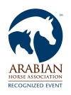

Owner Name____________________________________________________ (exactly as it appears on papers) AHA #____________________
Mailing Address_________________________________________________________ City/State/Zip___________________________________
Email Address__________________________________________________________ Phone_________________________________________
Manitoba Horse Council # (or a Equivalent Insurance) ________________________________________________________________________
Horse Name_____________________________ Registry _______ Registration # ___________ □Mare □Stallion □Gelding Year Foaled______
Exhibitor 1 Name_____________________________________ AHA ________________
Mailing Address_________________________ City/State/Zip_______________________
Email Address__________________________________ Phone____________________
Birthdate (MM/DD/YY) ___________ Relationship to Owner_________________________
Saturday Class #: _____ _____ _____ _____ _____ _____ _____ _____ _____ _____
Sunday Class #: _____ _____ _____ _____ _____ _____ _____ _____ _____ _____
Exhibitor 2 Name_____________________________________ AHA ________________
Mailing Address_________________________ City/State/Zip_______________________
Email Address__________________________________ Phone____________________
Birthdate (MM/DD/YY) ___________ Relationship to Owner_________________________
Saturday Class #: _____ _____ _____ _____ _____ _____ _____ _____ _____ _____
Sunday Class #: _____ _____ _____ _____ _____ _____ _____ _____ _____ _____
Exhibitor 3 Name_____________________________________ AHA ________________
Mailing Address_________________________ City/State/Zip_______________________
Email Address__________________________________ Phone____________________
Birthdate (MM/DD/YY) ___________ Relationship to Owner_________________________
Saturday Class #: _____ _____ _____ _____ _____ _____ _____ _____ _____ _____
Sunday Class #: _____ _____ _____ _____ _____ _____ _____ _____ _____ _____
Trainer Name_____________________________________ AHA ________________
Mailing Address_________________________ City/State/Zip_______________________
Email Address__________________________________ Phone____________________
____Class Fee (Per Class)@ $20 $______
_____Class Fee (*All Day) @ $75 $______
*All Day fee does not include any Sport Horse Classes
_____Office Fee @$15.00 per day $______
_____AHA Single Event Member Fee $______
@ $35/person/per show
_____Resolution 9-90 @ $4 per show $______
_____Stall/Tack (2 nights) @ $60 $______
_____Extra Stall (Per night) @$20 $______
_____ *Camping Per Night @ $25 $______
*(Limited plug ins)
_____ Arena Fee(not showing) @ $25 $_____
_____ Arena Fee(not showing) @ $25 $_____
___ **Red/Blue Dot Sale (Option One) @ $10 $____
___ **Red/Blue Dot Sale (Option Two) @ $40 $_____
**(Please check website for more info)
ENCLOSED TOTAL FEES $________
Make Check Payable to:

Manitoba Arabian Horse Association

Please read and complete release

ASSUMPTION OF RISK, RELEASE AND HOLD HARMLESS AGREEMENT
I agree as follows by signing this entry:
I choose for myself (or as parent or guardian to permit a junior exhibitor) to participate voluntarily in this competition. I AM FULLY AWARE AND ACKNOWLEDGE THAT PARTICIPATION IN THIS COMPETITION INVOLVES SERIOUS RISKS OF HARM, INCLUDING PERSONAL INJURIES, DEATH AND DAMAGES TO PROPERTY. I ASSUME ALL RISKS OF HARM AND DAMAGES TO ME, MY HORSE AND PROPERTY.
I hereby RELEASE, INDEMNIFY AND HOLD HARMLESS (including from damages, costs and attorney fees) Arabian Horse Association, the Competition, the facilities, and all of their respective Agents, Servants, Employees and Volunteers (Collectively the "Released Parties") from any claims, relating to the competition and my participation in the competition, belonging to me, or legally caused by me or my Horse, for any kind of damages, losses, or injuries to myself, other persons, horses or property to the fullest extent permitted by law. I further agree to adhere to the rules set forth in the Arabian Horse Association One Day Show Rules & Guidelines and understand all decisions made by the judge are deemed final and can not be protested.

___________________________ ___________________________ ___________________________
Exhibitor or Parent/Guardian Trainer Owner or Agent

___________________________ ___________________________ ___________________________
Date Date Date

